MATLAB-BASED MODELLING OF VSB MODULATOR AND DEMODULATOR FOR ANALOG TELEVISION COMMUNICATION APPLICATIONS
OBJECTIVES:
i) To generate and analyse the Vestigial Sideband (VSB) modulated signal by performing DSB-SC modulation and applying a suitable filter using MATLAB.
ii) To implement coherent demodulation and recover the original message signal from the VSB signal, and compare the transmitted and recovered waveforms.
PROGRAM (MATLAB CODE)
clc;
clear;
close all;
% Parameters
fs = 100000;
fm = 500;
fc = 5000;
t = 0:1/fs:0.02;
% 1. Message Signal
m = cos(2pifm*t);
% 2. Carrier Signal
c = cos(2pifc*t);
% 3. DSB-SC Modulation
dsb = m .* c;
% 4. VSB Signal (Approximation)
alpha = exp(-2pi1000/fs);
vsb = zeros(size(dsb));
for n = 2:length(dsb)
vsb(n) = alpha*vsb(n-1) + (1-alpha)*dsb(n);
end
% 5. Coherent Demodulation
demod = vsb .* (2cos(2pifct));
% 6. Recover Message Signal
rec = zeros(size(demod));
for n = 2:length(demod)
rec(n) = alpha*rec(n-1) + (1-alpha)*demod(n);
end
% Normalize recovered signal
rec = rec / max(abs(rec));
% Plot all signals
figure('Color','w');
subplot(5,1,1);
plot(t,m,'b','LineWidth',1);
title('Message Signal');
ylim([-1.1 1.1]);
xlim([0 0.02]);
grid on;
subplot(5,1,2);
plot(t,c,'b','LineWidth',1);
title('Carrier Signal');
ylim([-1.1 1.1]);
xlim([0 0.02]);
grid on;
subplot(5,1,3);
plot(t,dsb,'b','LineWidth',1);
title('DSB-SC Signal');
ylim([-1.1 1.1]);
xlim([0 0.02]);
grid on;
subplot(5,1,4);
plot(t,vsb,'b','LineWidth',1);
title('VSB Signal');
xlim([0 0.02]);
grid on;
subplot(5,1,5);
plot(t,rec,'r','LineWidth',1.2);
title('Recovered Message');
xlabel('Time (seconds)');
ylim([-1.1 1.1]);
xlim([0 0.02]);
grid on;
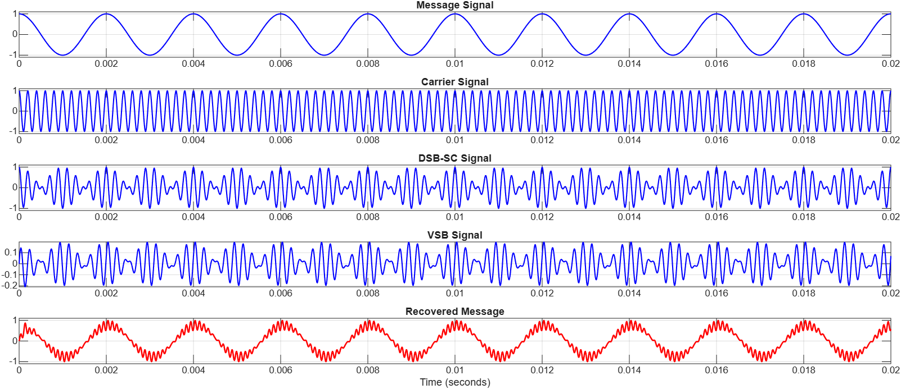
OUTPUT (GRAPH)
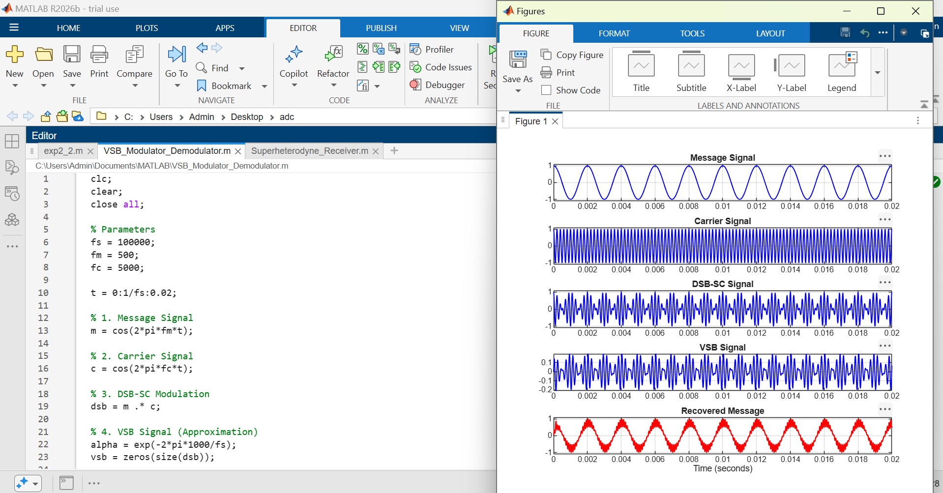

RESULT :
i) The VSB modulated signal was successfully generated from the DSB-SC signal using MATLAB and verified through the displayed waveforms.
ii) The original message signal was successfully recovered through coherent demodulation and low-pass filtering, confirming the correct implementation of the VSB communication system.

